User Guide

Contents

Starting the program 2

Connecting to the server 2

Logging In 2

Signing Up 3

Your profile & account balance 3

Browse & rent games 4

# Starting the program

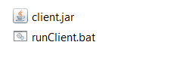To start the program, locate the Client.jar file. Double clicking on the java file should work, but if you encounter any issue try running the runClient.bat file.

# Connecting to the server

When the program is successfully started, you will first be given a prompt to enter the IP address of the sever to connect to.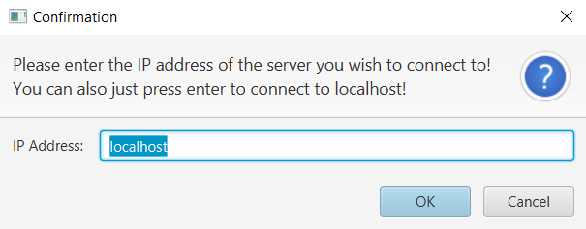

Logging In

After stating the server to which you would like to be connected, you will encounter the login window.  
  
Here you are to type in your username (1) and password (2) so that you may access your profile.  
  
After you have typed in your information press the **Login** button (3).  
  
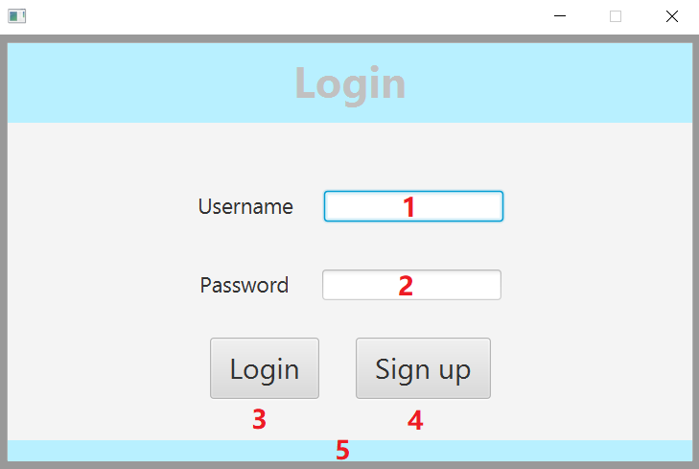

If you get the message:” **User does not exist on server**” in the bottom of the screen (5), it means that you are either not signed up or that your username or password are incorrect.

In case you are not signed up you may press the **Sign up** (4) to do so.

# Signing Up

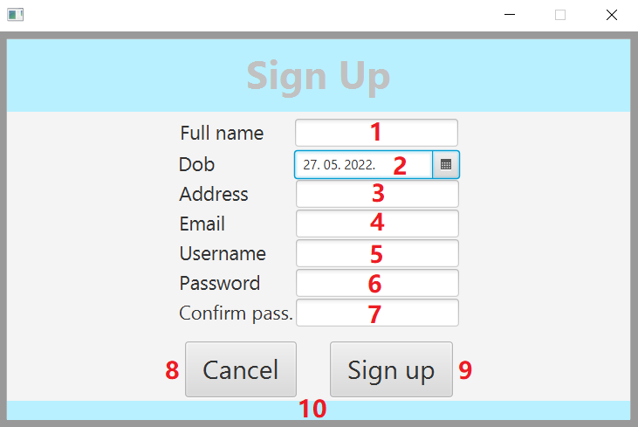To create a profile, you need to provide your full name (1), date of birth* (2), address (3), email address (4), username you wish to use (5), password you wish to use (6) and confirmation of the password (7). The order in which you fill out the form does not matter.  
After you have fully filled out the form you should press the **Sign up** button (9). If the information entered is not sufficient, helpful information will appear at the bottom of the window (10) to remedy the situation. You can cancel the process of signing up at any point by pressing the **Cancel** button (8).

* **WHEN GIVING YOUR DATE OF BIRTH PLEASE NOT THAT YOU MUST NOT TYPE IT IN BUT INSTEAD USE CLENDAR OPENED BY CLICKING THE SYMBOL NEXT TO THE FIELD.**

# Your profile & account balance

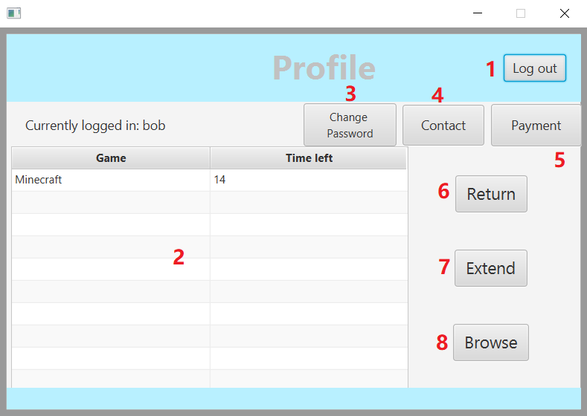After you successfully logging in you will see your profile page with your currently rented games and how many days you have left before you need to return them (2).  
  
If you wish to log out, you may press the **Log out** button (1). Doing so will log you out and return you to the login screen.  
  
If you wish to change your password, you are to press the **Change Password** button and state the new password. Please note that it still must follow the rules for creating a password.

In case you need to have any of your other information changed, you must contact the administrators by writing them an email. You may see emails of all administrators by pressing the **Contact** button (4).

To rent a new game, you must press the **Browse** button (8) which will take you to screen where you may browse and filter games that are available at the time.

If you wish to extend the amount of time you may have a game, you can extend it by clicking on the game you wish to extend and pressing the **Extend** button (7). After this you must confirm that you wish to extend the selected game. Doing this will extend the time left by 5 days. Please note that you may only extend a game twice.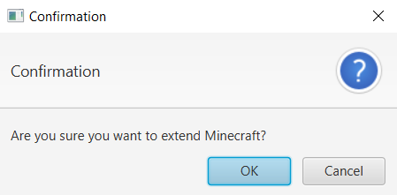

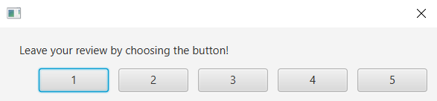To return a game you have rented, you first must select the game that you want to return and press the **Return** button (6). You will be asked to review the game. To do so you must choose a number ranging from 1 to 5 with which you would represent you satisfaction with the game with 5 representing the highest satisfaction.

To manage your account balance and subscription you should press the **Payment** button (5).

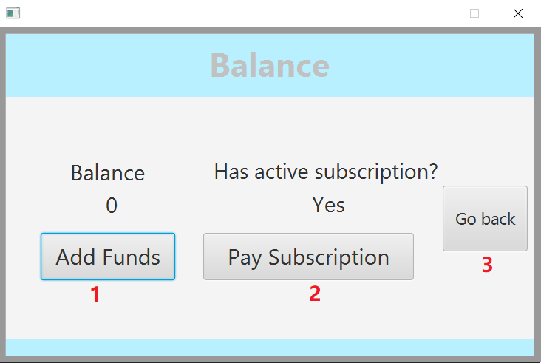In the balance screen you can see the current balance of your account and if you have an active subscription.   
  
You are also able to add money to your account by pressing the **Add Funds** button (1).  
  
To pay for your subscription you must press the **Pay Subscription** button (2). The subscription costs 30 currency and it is needed to rent games.

If you wish to return to your profile page, you can press the **Go back** button (3).

# Browse & rent games

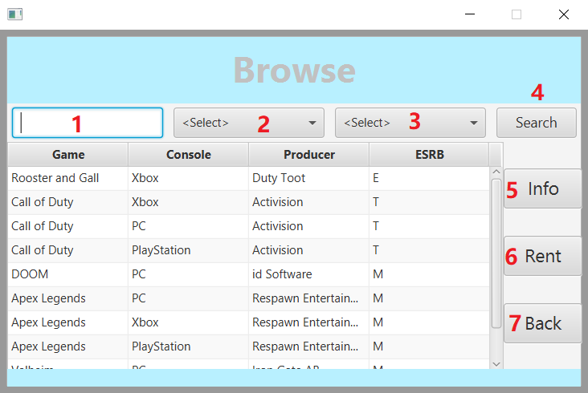When browsing games, you can scroll through all currently available games. If you are looking for a game that fits a certain criterion, you can filter the game selection.   
  
You can search games by name (1), console (2) or ESRB rating (3). To apply the selection, you must press the **Search** button (4).

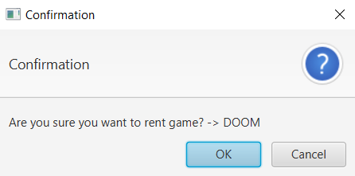If you wish to rent a game you find interesting, you must first click on it and press the **Rent** button. You must then confirm that you wish to rent the selected game. Once confirmed, your 14-day rental period will begin.

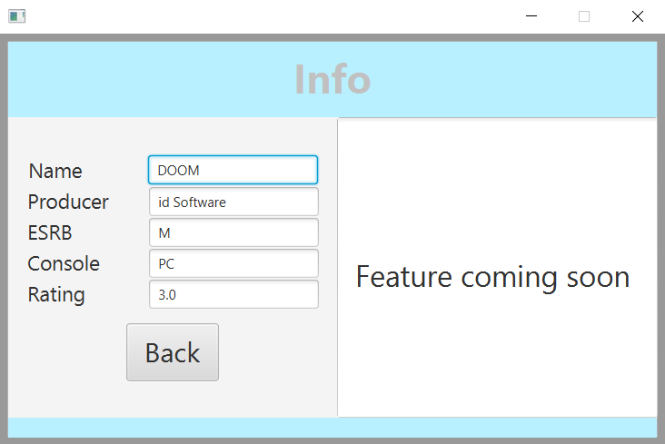If you wish to see more detailed information of any game, you can   
do so by clicking on the game and pressing the **Info** button (5).  
  
You are now able to rent a wide variety of games for multiple platforms, so make sure to give a try. Also please try to return your games on time, and most importantly, have fun!

We hope that this manual has helped you with any questions you had. If there are any unanswered questions, hard to understand or if you simply have any input you wish to give regarding the manual you just read you can contact the author at the following email.

315258@viauc.dk